Monday | Tuesday | Wednesday | Thursday | Friday
Nov 11  Practice 3:30-5 | 12  Practice 3:30-5 | 13  Practice 3:30-5 | 14  Game @Field 5:30 & 6:30 | 15  Practice to 4:15
18  Practice 3:30-5 | 19  Practice 3:30-5 | 20  Practice 3:30-5 | 21  Game @ Blalack vs. Bush 5:30 & 6:30 | 22  HOOPS FOR HEART $1
25  Thanksgiving Break | 26  Thanksgiving Break | 27  Thanksgiving Break | 28  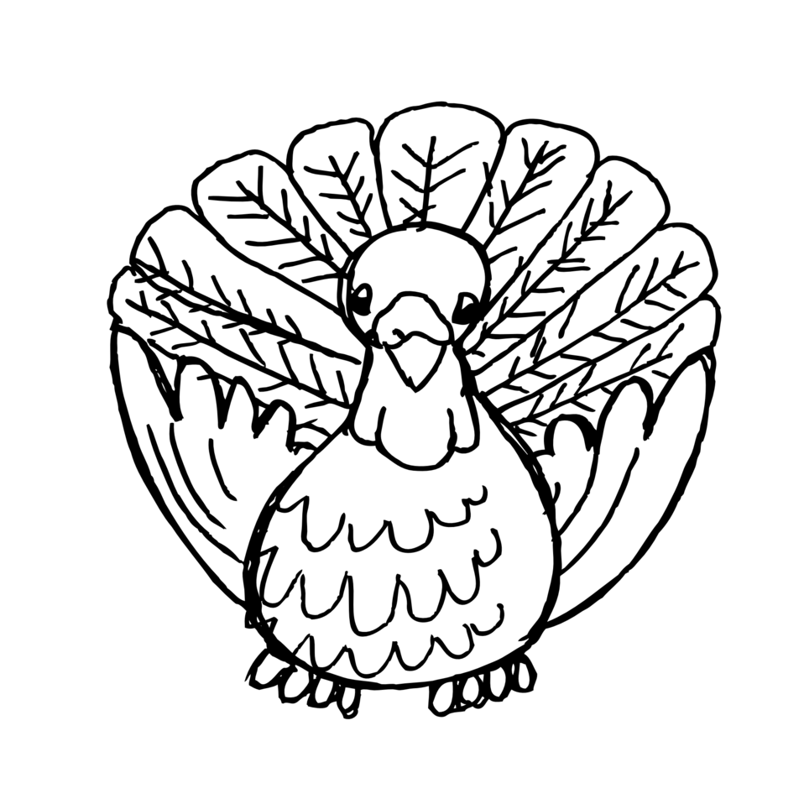 | 29  Thanksgiving Break
Dec 2  Practice 3:30-5 | 3  Practice 3:30-5 | 4  Practice 3:30-5 | 5  Game @ Polk 5:30 & 6:30 | 6  Practice 3:30-4:15
9  Practice 3:30-5 | 10  Practice 3:30-5 | 11  Practice 3:30-5 | 12  Game vs Perry  5:30 & 6:30 | 13  Practice 3:30-4:15
16  Practice 3:30-5 | 17  Practice 3:30-5 | 18  Practice 3:30-5 | 19  Game @ Long 5:30 & 6:30 | 20  Holiday Party! 4:15-4:45  Merry Christmas!

Monday | Tuesday | Wednesday | Thursday | Friday
Jan 6  NO SCHOOL | 7  Practice 3:30-5 | 8  Practice 3:30-5 | 9  Game @ Blalack vs. Field 5:30 & 6:30 | 10  Practice 3:30-4:15
13  Practice 3:30-5 | 14  Practice 3:30-5 | 15  Game @ Bush  5:30 & 6:30 | 16  Practice 3:30-5 | 17  Practice 3:30-4:15
20  NO SCHOOL | 21  Practice 3:30-5 | 22  Game vs Polk  A Team Only 6:30 | 23  Practice 3:30-5 | 24  Practice 3:30-4:15
27  Practice 3:30-5 | 28  Practice 3:30-5 | 29  Practice 3:30-5 | 30  Game @ Perry  5:30 & 6:30 | 31  A-Team Tournament

****Friday, Saturday, January 31-Feb 1: A Team Tournament: Location TBD****

